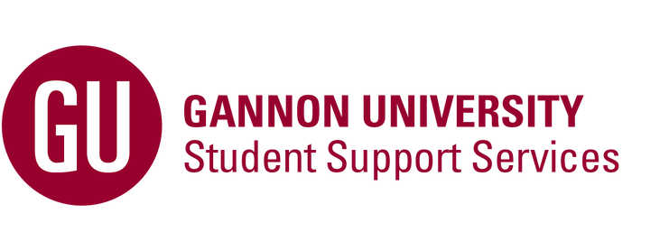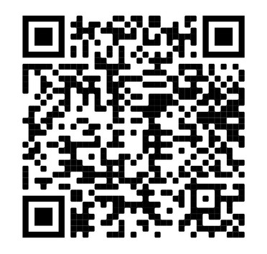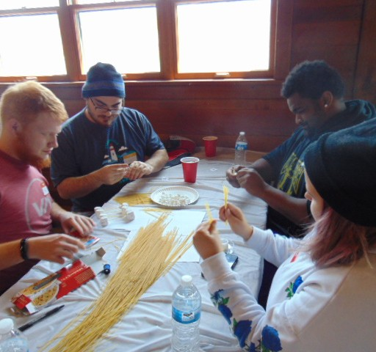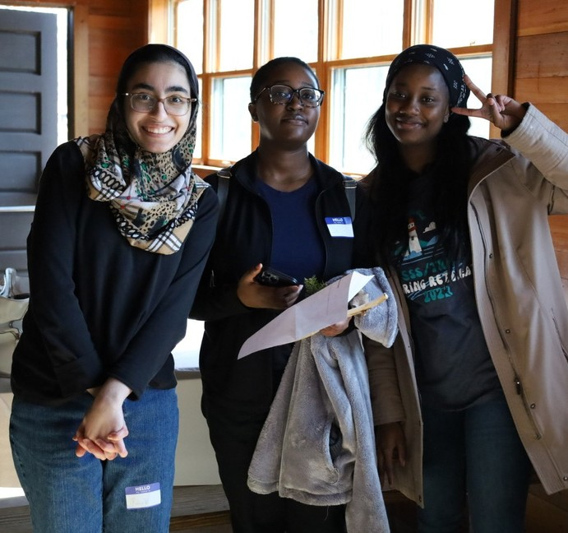

**Who is Eligible?**

US Citizen, permanent resident, or eligible for Federal Student Aid; and

Admitted or enrolled at Gannon University in a bachelor degree program; and

Meets at least one of the following criteria

First-generation college status" Parent(s)/Guardians(s) did not complete a four-year college degree

Income Eligible: Federally determined using FAFSA output or taxable income and number of exemptions on most recent federal taxes

Disability status: Documentation accepted includes: IEP,

M.D. verification, letter from Gannon Disability Support Services, or government sources

Did You Know?

Students in the TRIO Student Support Services program are more than twice as likely to remain in college as those students from similar backgrounds who did not participate in the program. - *Council for Opportunity in Education*

**What do you get from SSS?**

**Peer Mentoring**

**Academic & Career Advising Course Selection & Scheduling Assistance**

**FAFSA & Financial Aid Process Assistance**

**Graduate School Visits & Cultural Trips**

**Priority Registration Proactive Tutoring Study Space Computer Lab**

**Student Support Services (SSS/TRIO) Palumbo Academic Center**

**Student Success Center (SSC)**

**814-871-7680 | Scan the QR code to apply**